Powerful Public Computing Programs
with Low-To-No Budgets

1. Include ALL THREE PARTS of public computing

3. LITERACY = Cybernavigators (or tech volunteers) + community organizing
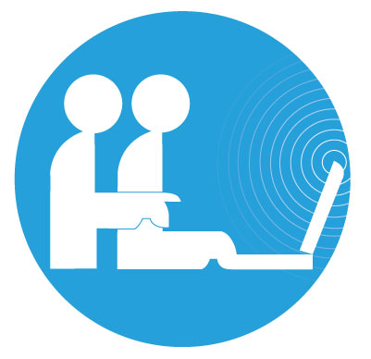

2. ACCESS = Machines + Internet + IT support

4. CONTENT = Email + Job hunting + Digital Media + Local & Family history + Wikis + Health + eBooks
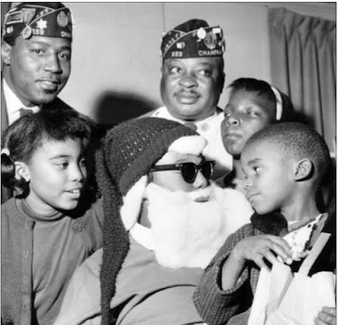

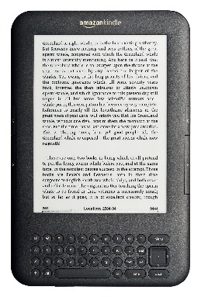

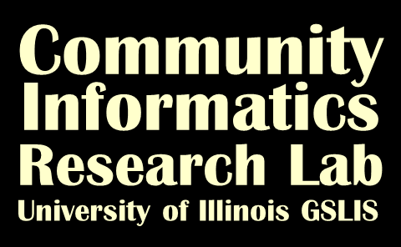

Links for more information:
Three aspects of public computing: http://www.seattle.gov/tech
Free logo and comic: http://echicago.illinois.edu
Local wiki movement: http://localwiki.org and http://cuwiki.net/
eBlackChampaign-Urbana: http://eblackcu.net/
Presenters Kate Williams and Noah Lenstra:
http://people.lis.illinois.edu/~katewill/
http://www.noahlenstra.com

